John Pratt

Robustness Diagram – Movie Select

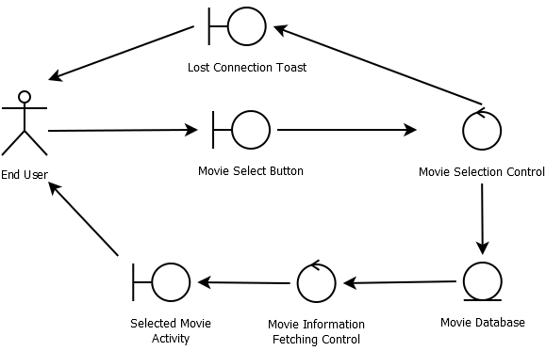

Joshua Jibilian

Robustness Diagram – Register User

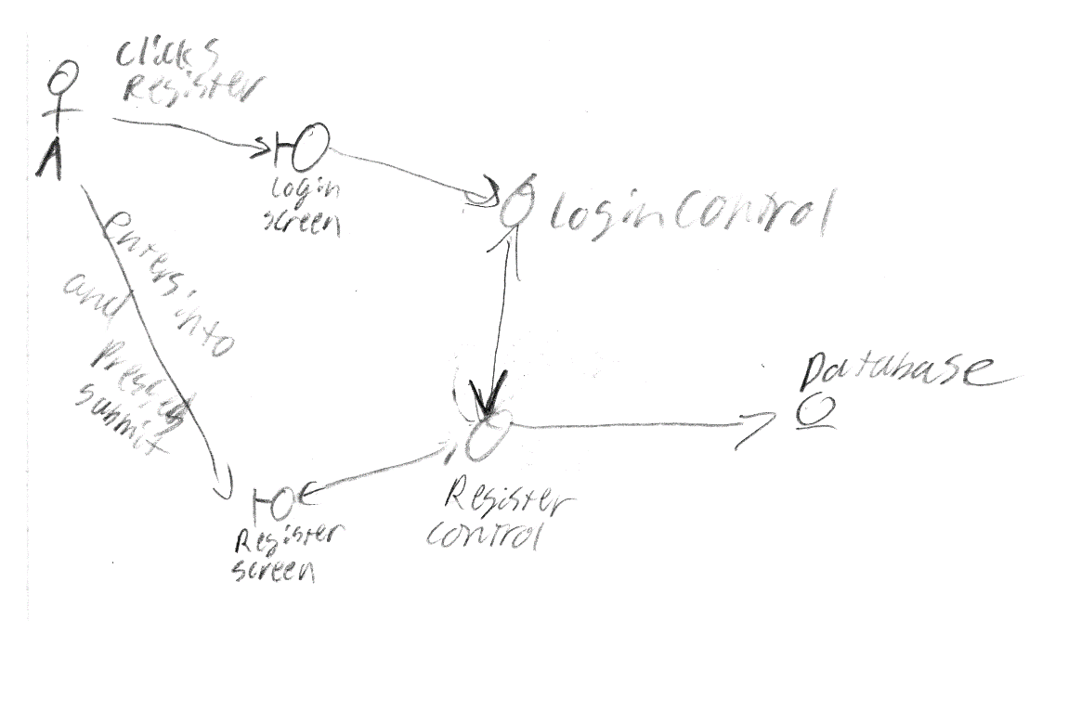

Christian Girala

Robustness Diagram for “Welcome Screen”

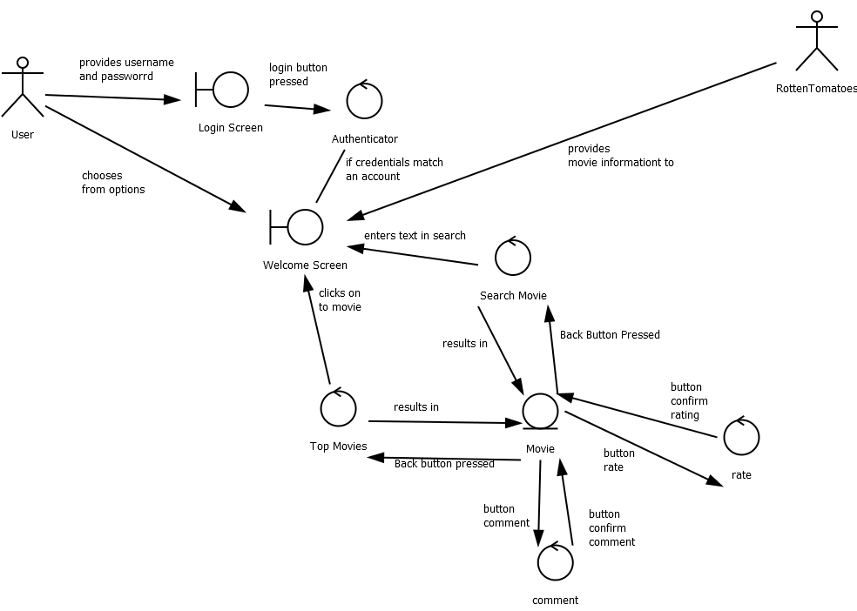

Joshua Valdez

Robustness Diagram for “Report Comment”

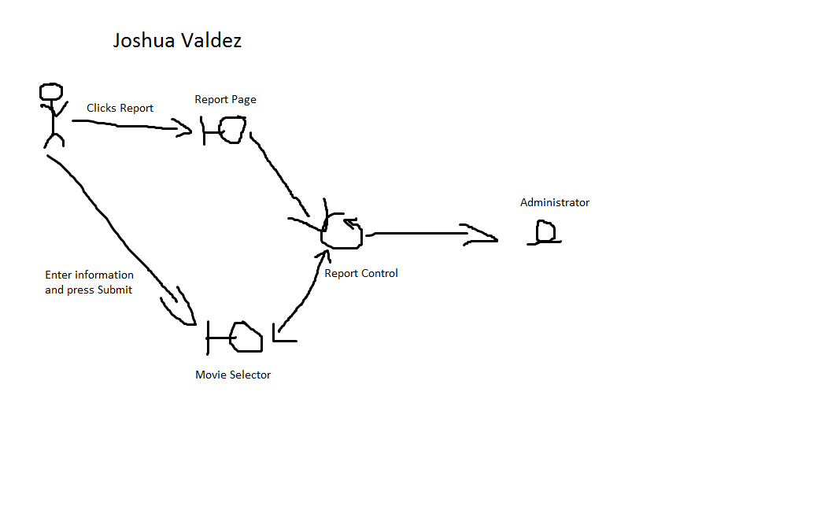

Diptodip Deb

Robustness Diagram for “Search Movie”

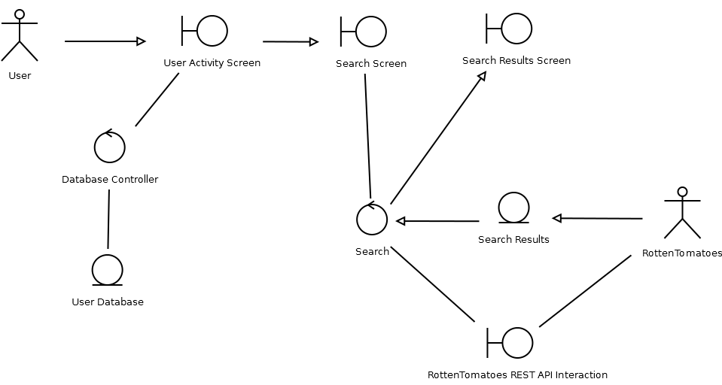

UI Flow Diagram

